Present Value with Compound Interest – Annotated Examples
  - Liberal Arts Mathematics

Introduction
There is a lot going on in the compound interest formula. It looks complicated and has several steps. Once you learn to focus on working one step at a time, it becomes more manageable. Here are two examples shown step-by-step with the corresponding calculator steps.

Examples
The following example is Example 6.44 from Contemporary Mathematics by Donna Kirk.
The main tip I suggest to students is to keep your work in your calculator. We will have to use the calculator memory to perform the last division. There are other ways to do this calculation. The method shown will work on almost every calculator. I am showing how I type the calculations in the Microsoft Windows calculator. Almost all scientific calculators are similar.
The denominator (bottom of the fraction) is very similar to the formula for future value. This means you already know how to use most of the present value formula.

Example
In the following, compute the future value of the investment with the given conditions.
- Future value is $1,000,000, annual interest rate is 5.75%, compounded monthly, for 40 years.
- Principal is $175,000, annual interest rate is 3.8%, compounded quarterly, for 20 years.

Solution 1
Step | Calculator | Work
Start with the formula  $$P=\frac{A}{{\left(1+\frac{r}{n}\right)}^{n⋅t}}$$  Substitute the known values |  | 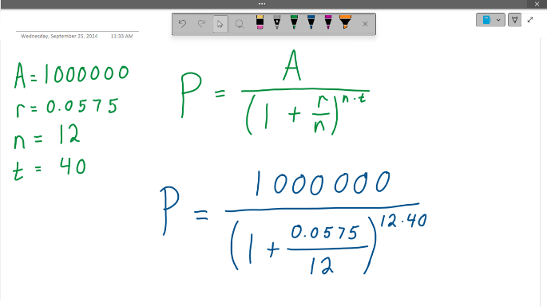
The first operations are division inside the parentheses and multiplication in the exponent. | 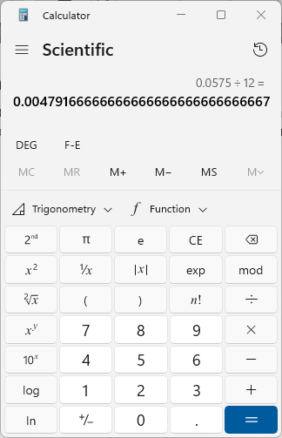 | 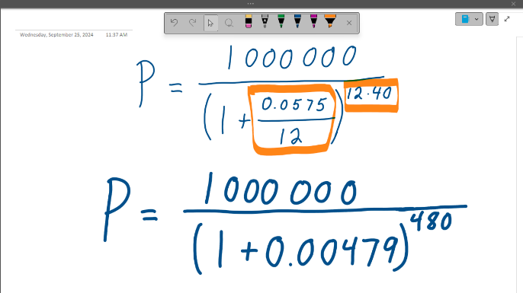
The second operation is addition inside the parentheses | 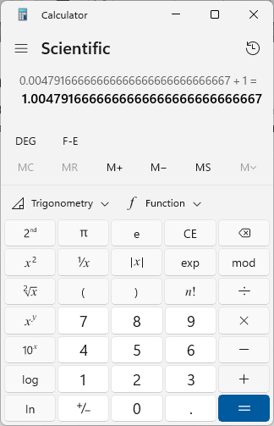 | 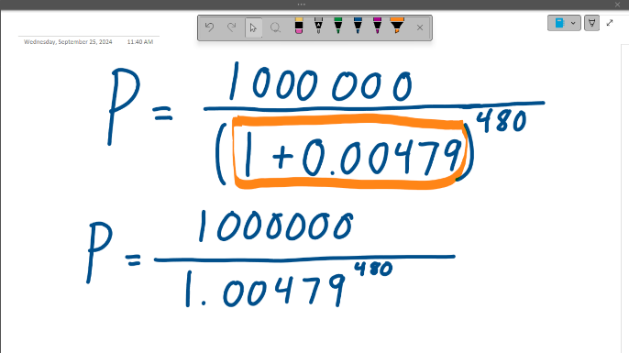
The third operation is the exponent.  This is where round-off errors start to matter. | 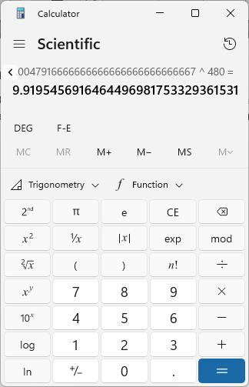 | 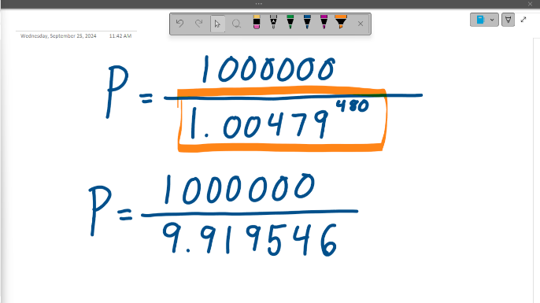
The fourth and final operation is division.  Press “M+” to store the last answer. Type 1000000, divide, then “MR” to use the last calculation (9.919546).  The present value is $100,811.07. | 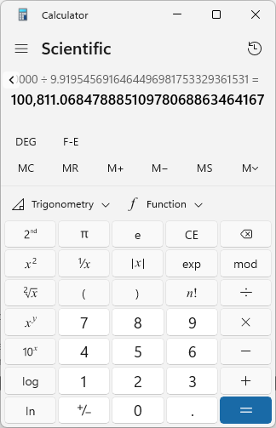 | 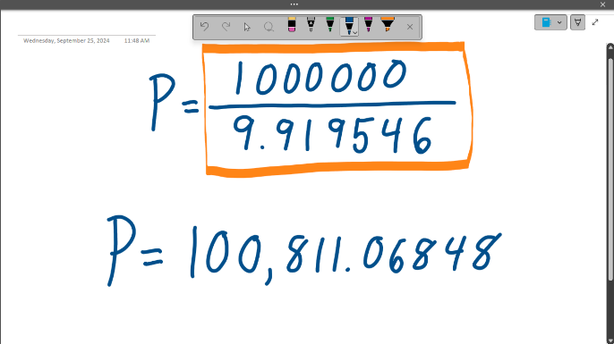

Solution 2
Step | Calculator | Work
Start with the formula  $$A=P{\left(1+\frac{r}{n}\right)}^{n⋅t}$$  Substitute the known values |  | 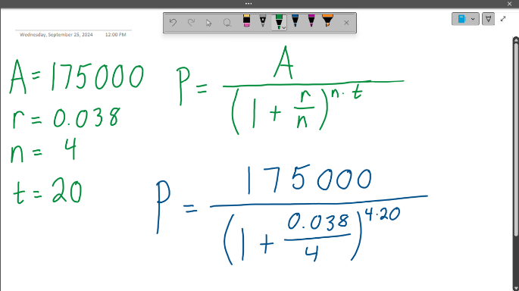
The first operations are division inside the parentheses and multiplication in the exponent. | 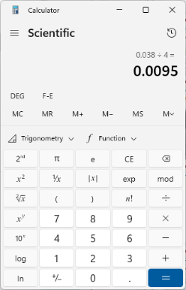 | 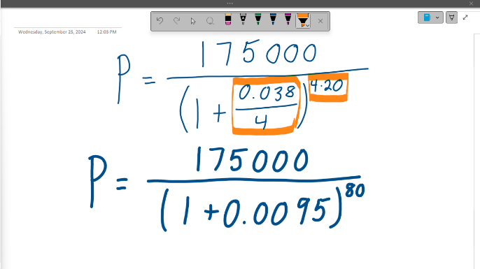
The second operation is addition inside the parentheses | 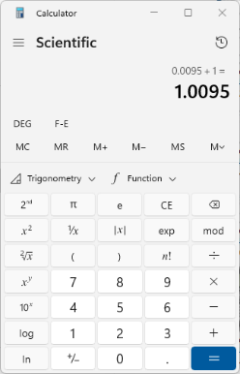 | 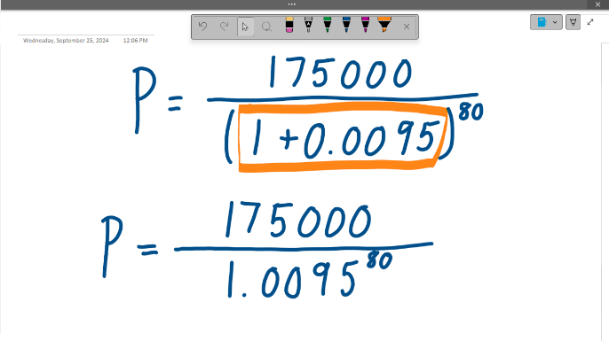
The third operation is the exponent.  This is where round-off errors start to matter. | 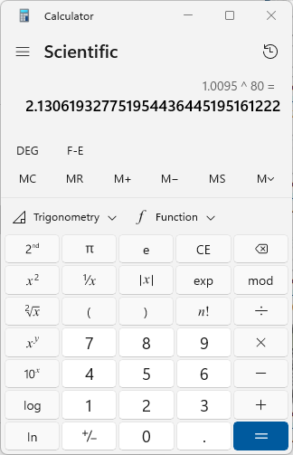 | 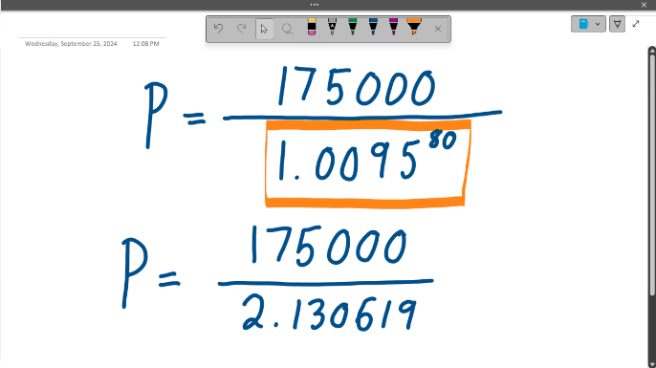
The fourth and final operation is division .  Use the same calculator steps as before.  The present value is $82,135.75. | 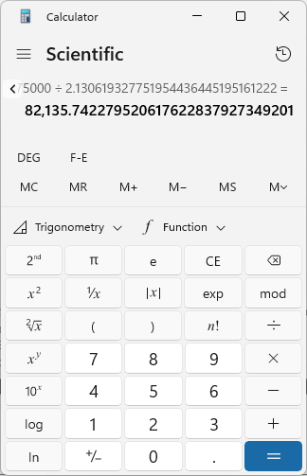 | 