Future Value with Compound Interest – Annotated Examples
  - Liberal Arts Mathematics

Introduction
There is a lot going on in the compound interest formula. It looks complicated and has several steps. Once you learn to focus on working one step at a time, it becomes more manageable. Here are two examples shown step-by-step with the corresponding calculator steps.

Examples
The following example is Example 6.41 from Contemporary Mathematics by Donna Kirk.
The main tip I suggest to students is to keep your work in your calculator. It is easy to get round-off errors in these problems. I am showing how I type the calculations in the Microsoft Windows calculator. Almost all scientific calculators are similar.

Example
In the following, compute the future value of the investment with the given conditions.
- Principal is $5,000, annual interest rate is 3.8%, compounded monthly, for 5 years.
- Principal is $18,500, annual interest rate is 6.25%, compounded quarterly, for 17 years.

Solution 1
Step | Calculator | Work
Start with the formula  $$A=P{\left(1+\frac{r}{n}\right)}^{n⋅t}$$  Substitute the known values |  | 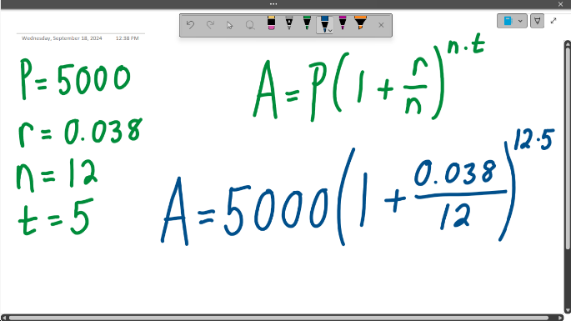
The first operations are division inside the parentheses and multiplication in the exponent. | 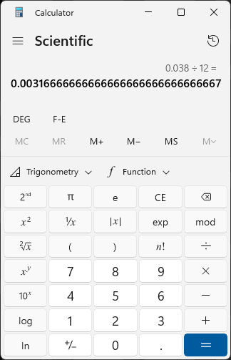 | 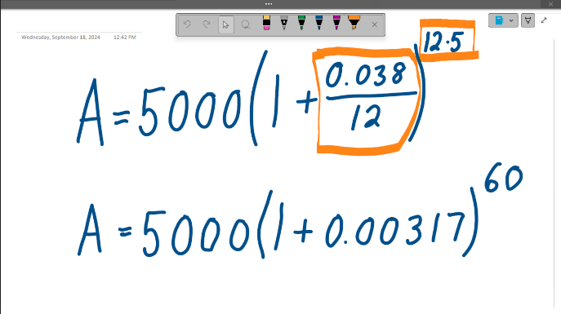
The second operation is addition inside the parentheses | 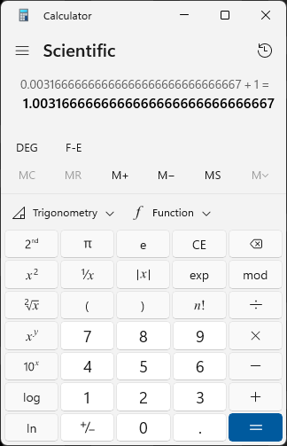 | 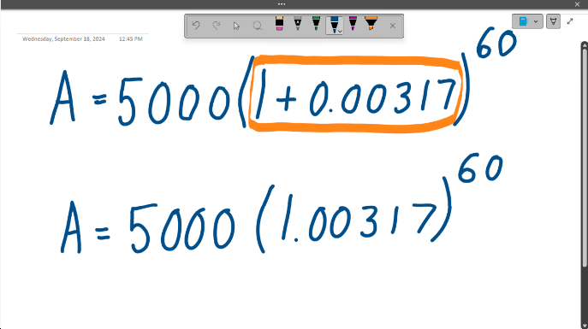
The third operation is the exponent.  This is where round-off errors start to matter. | 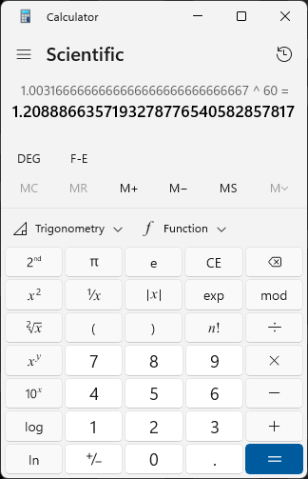 | 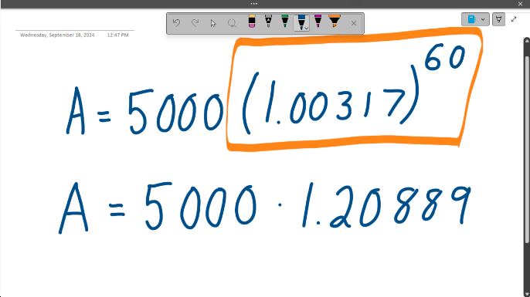
The fourth and final operation is multiplication.  The future value is $6,044.43 | 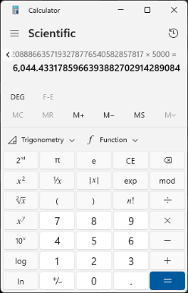 | 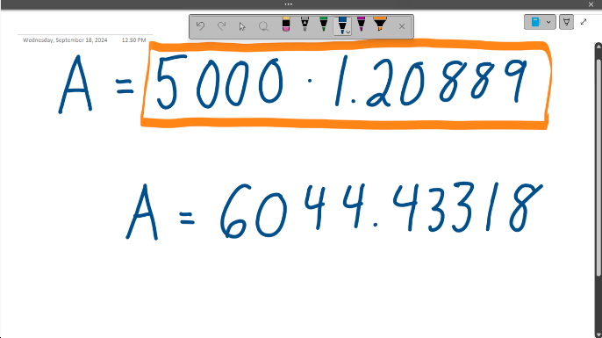

Solution 2
Step | Calculator | Work
Start with the formula  $$A=P{\left(1+\frac{r}{n}\right)}^{n⋅t}$$  Substitute the known values |  | 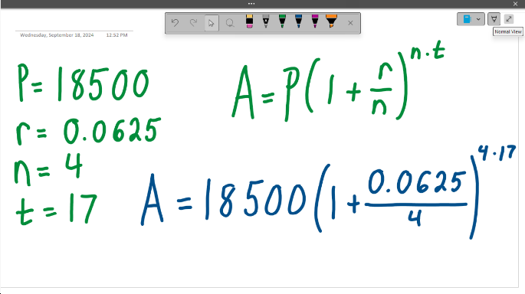
The first operations are division inside the parentheses and multiplication in the exponent. | 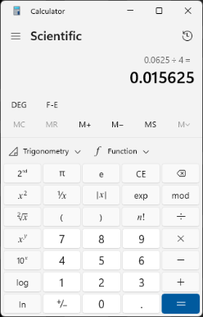 | 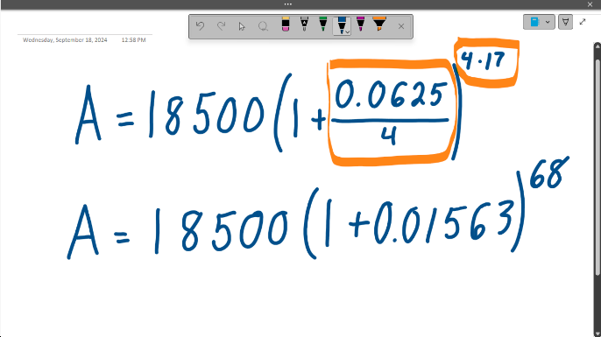
The second operation is addition inside the parentheses | 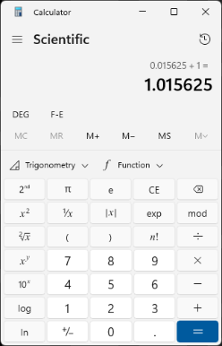 | 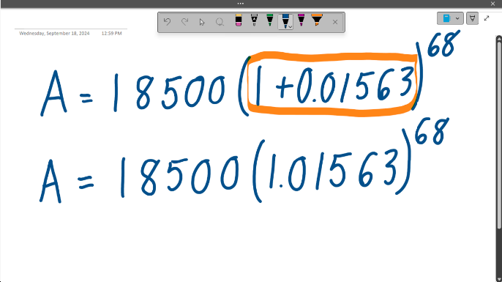
The third operation is the exponent.  This is where round-off errors start to matter. | 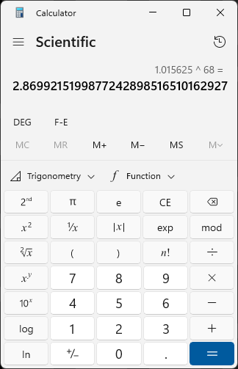 | 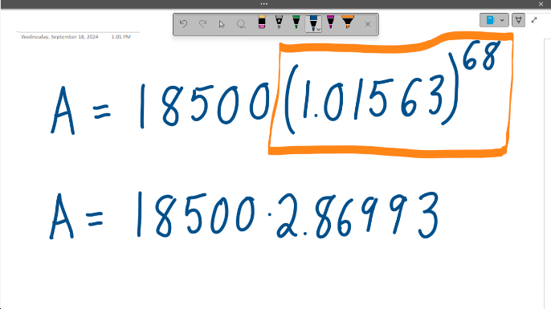
The fourth and final operation is multiplication.  The future value is $53,093.55 | 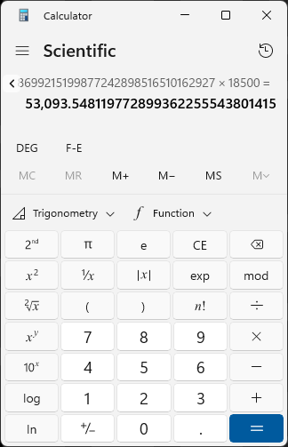 | 