Solving Linear Equations
  - College Algebra

Introduction
Solving linear equations is an important part of intermediate algebra. We need to solve some linear equations in this course, but we will not go as in depth as in previous algebra courses.

Definition of Linear Equations

Definition – Linear Equation
A linear equation is any equation without an exponent on the variable or without a variable in a denominator.

Basic Operations
The basic rules for solving linear equations are as follows. They are often written in a symbolic form. We will write them here in the form most people remember.
- You can add or subtract the same quantity from both sides of an equation and not change the solutions.
- You can multiply or divide the same quantity (except 0) to both sides of an equation and not change the solutions.

Combining Like Terms
The last rule we need for solving linear equations is combining like terms. Combining like terms is more involved for polynomial equations. Fortunately, it is much simpler for linear equations.

Definition – Like Terms
For a linear equation, two terms are like terms if they have the same variable.

Procedure – Combining Like Terms
To combine like terms, add the coefficients and keep the variable the same.

Example 1
﻿Combine like terms: $4x-8x$.﻿

Solution
Step | Work
The coefficients are 4 and -8. Add 4 and -8 to get -4. The answer after combining like terms is $-4x$. | 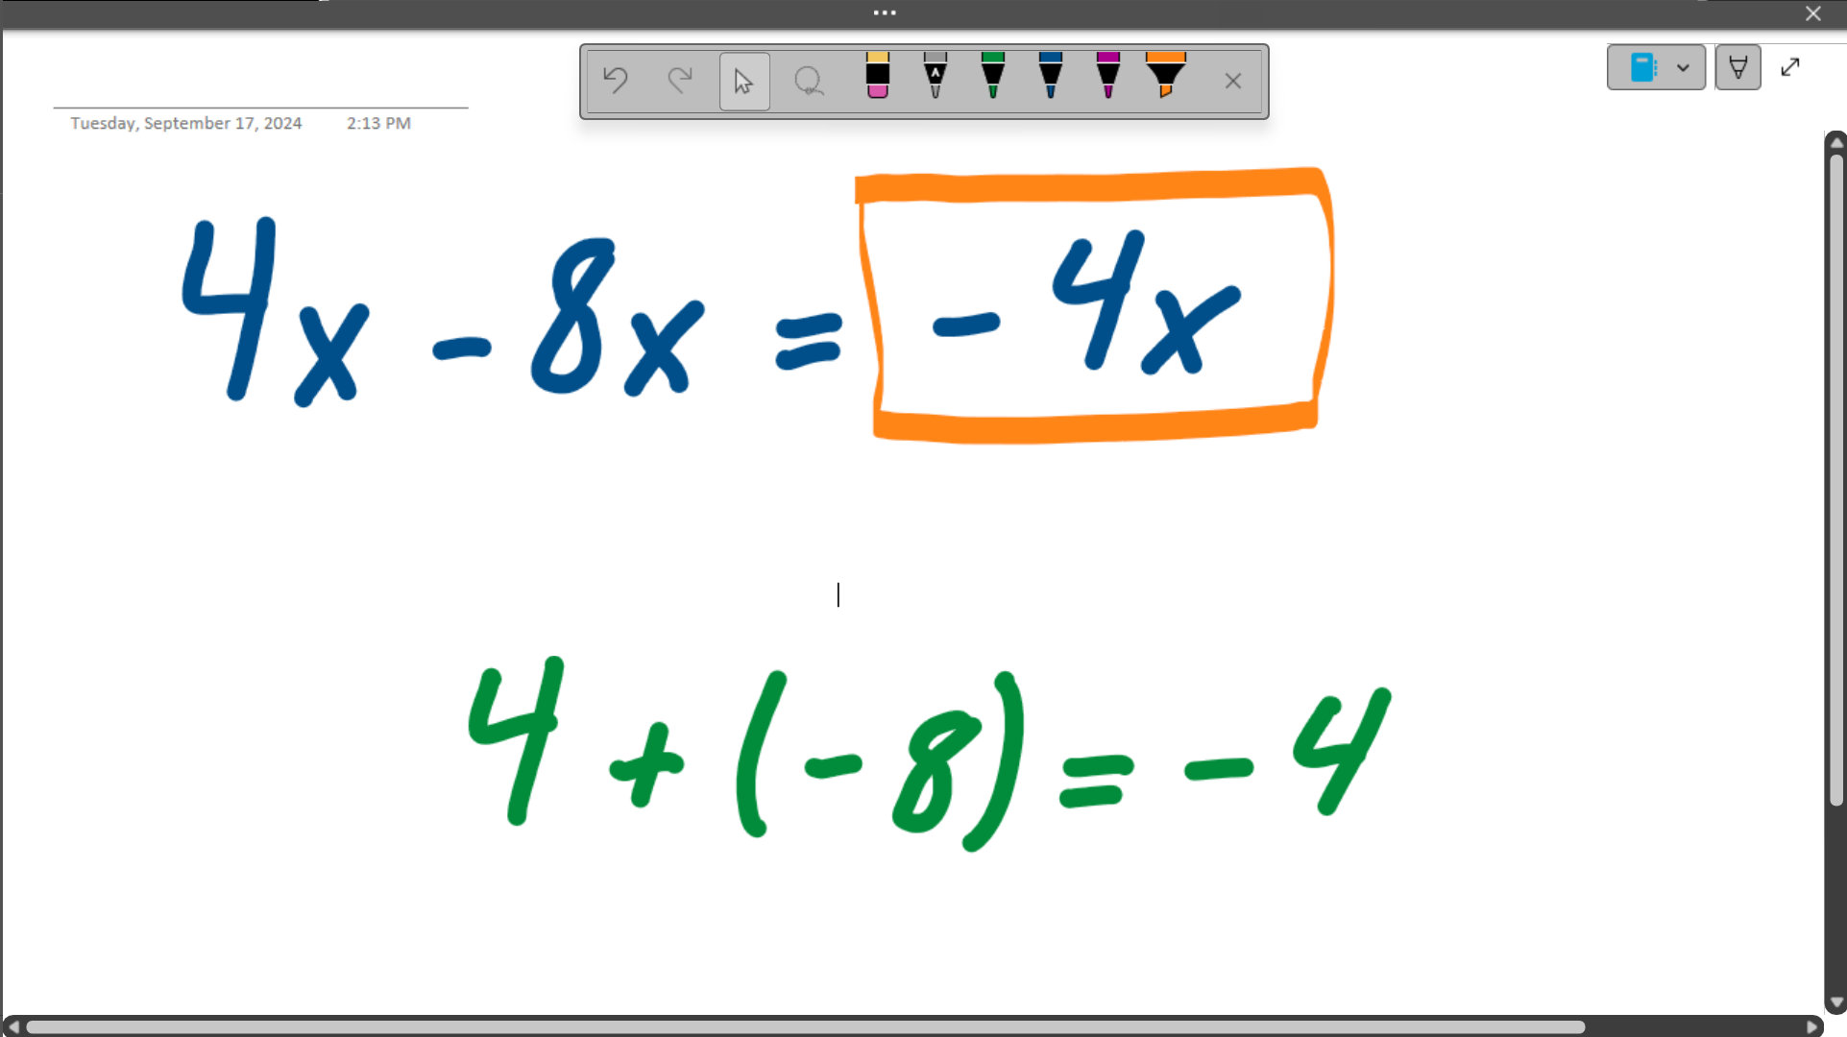

Example 2
Combine like terms: $3c+bc+c$.

Solution
Step | Work
The coefficients are 3, $b$, and 1. (If we do not write the coefficient, the coefficient is 1.) Add the coefficients to get $4+b$. (Remember that you cannot combine constants and variables.) The answer is $\left(4+b\right)c$. | 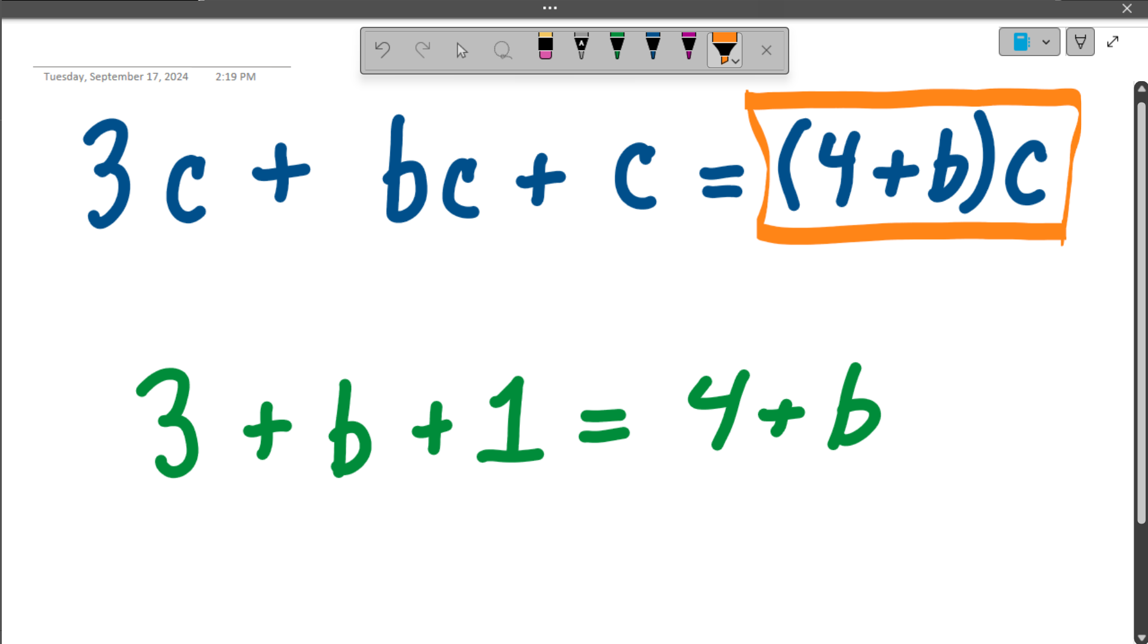

Solving Linear Equations
My way of describing the process of solving a linear equation is “Always be Cancelling.” This is a riff on the famous speech from the movie Glengarry Glen Ross.

Procedure – Solving a Linear Equation
- Cancel one variable term by adding or subtracting a term from both sides of the equation.
- Cancel one constant term by adding or subtracting the constant from the side containing the variable.
- Cancel the coefficient by diving both sides of the equation by the coefficient.

Example 3
Solve the equation for $x$.
$$5x+3=x-14$$

Solution
Step | Work
Start by subtracting $x$ from both sides. | 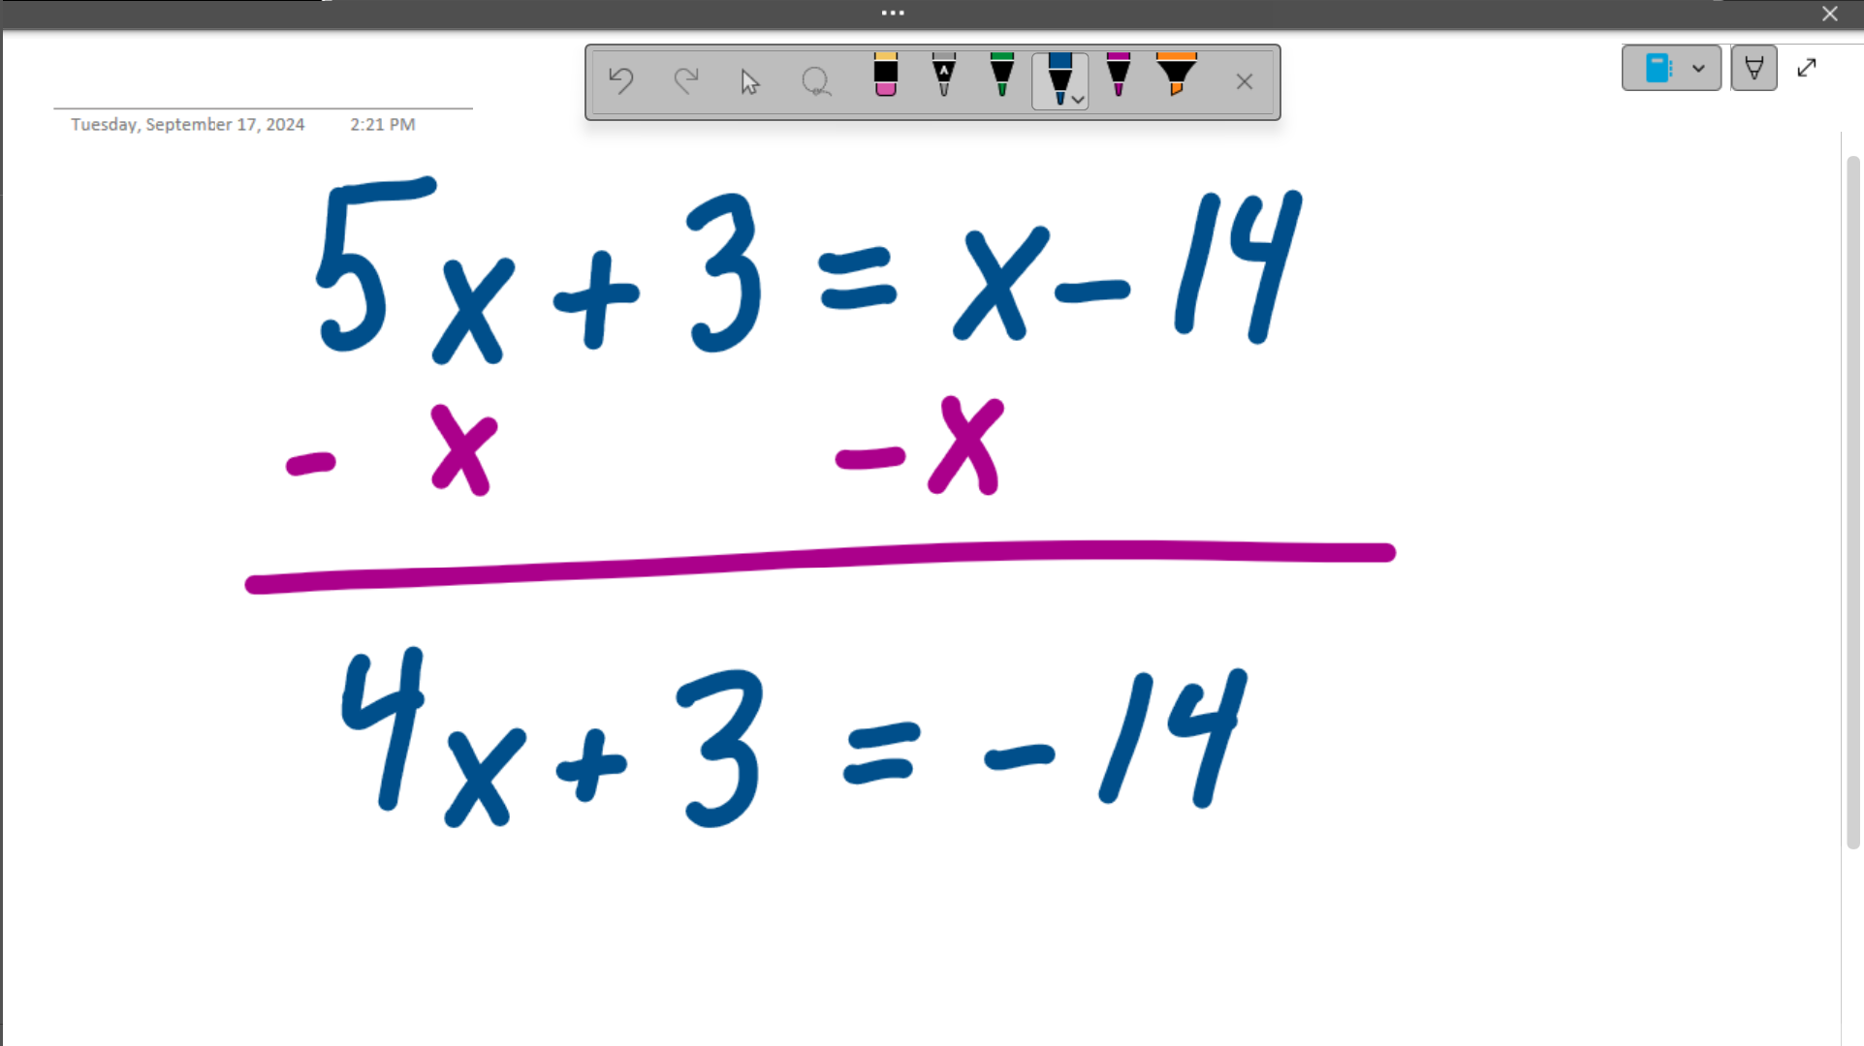
Subtract 3 from both sides. | 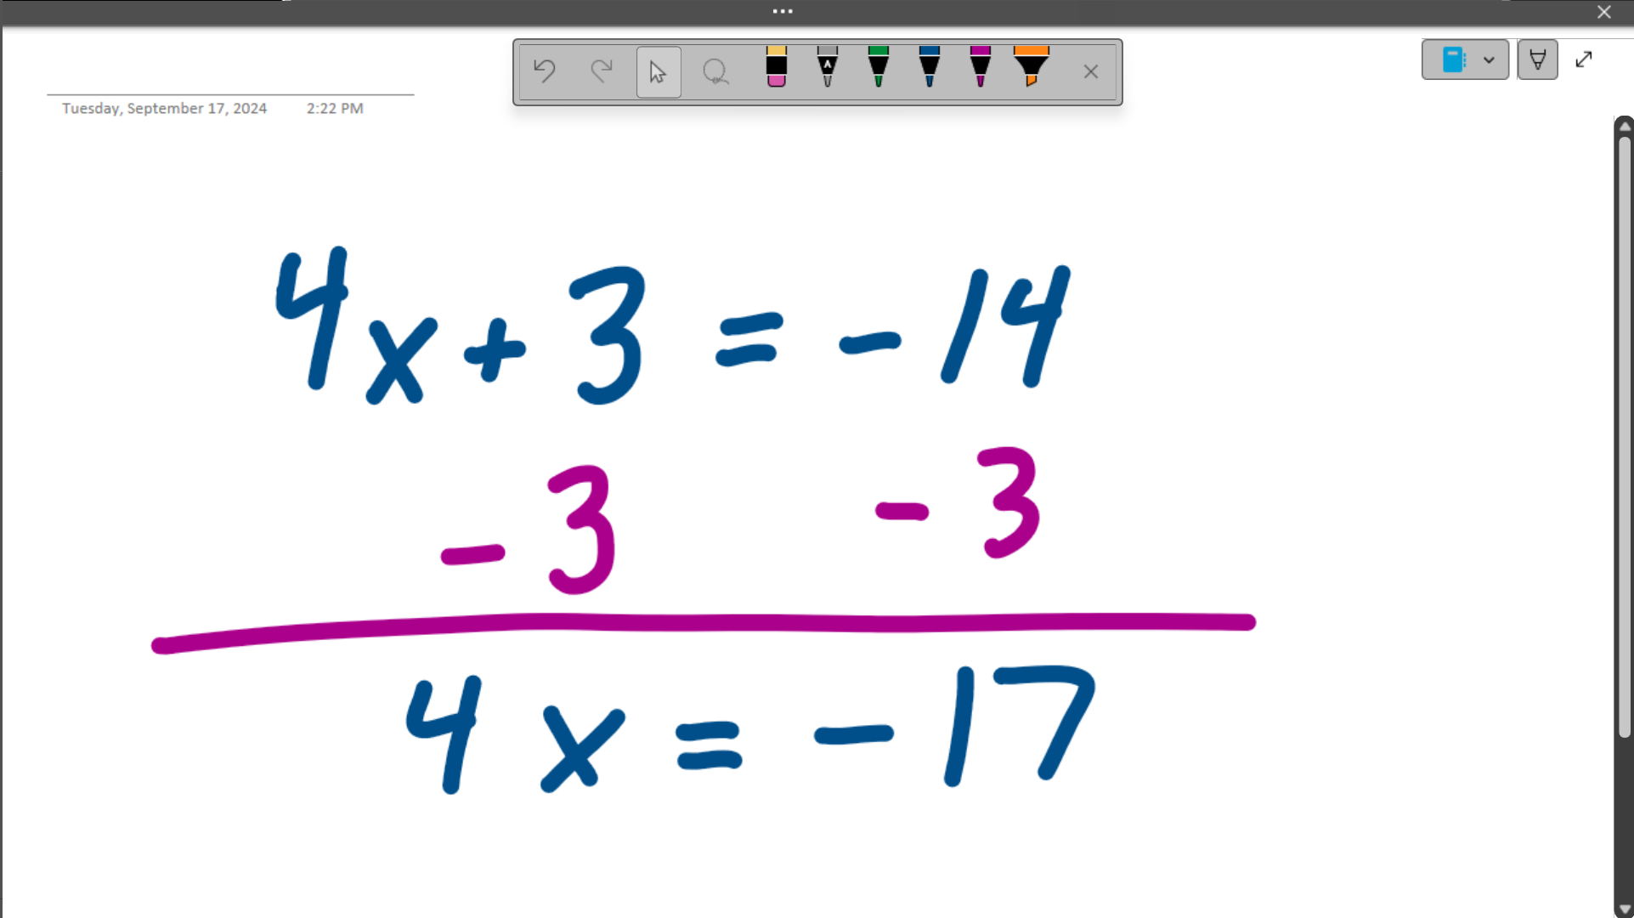
Divide both sides by 4.  The solution is $x=-\frac{17}{4}$. | 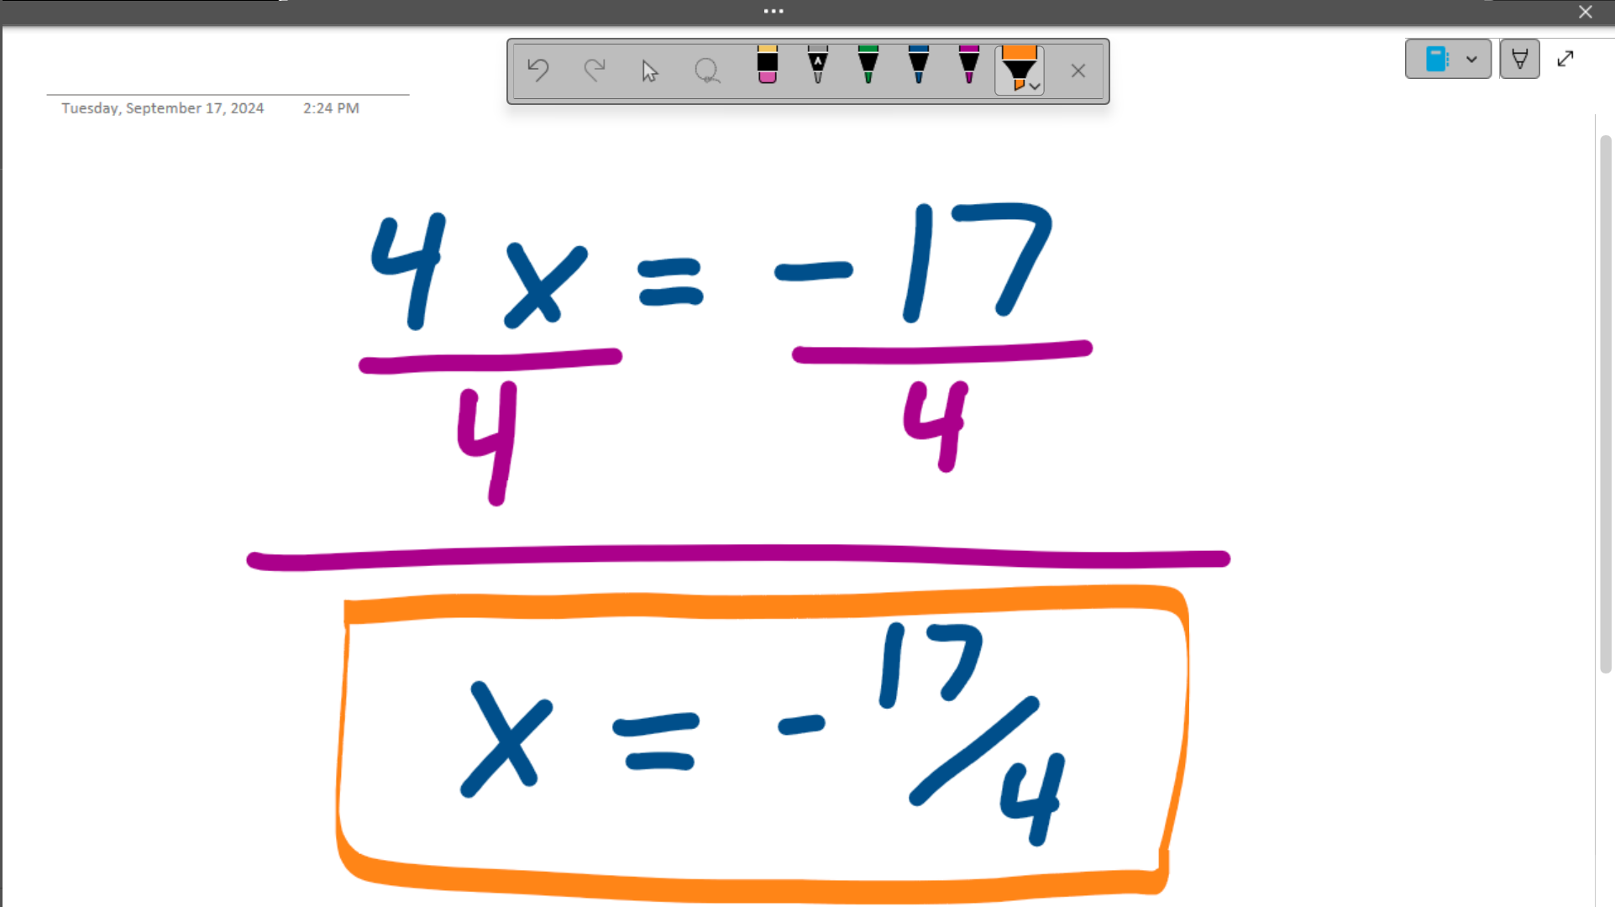

Example 4
Solve the equation for $x$.
$$12x-9=15x+14$$

Solution
Step | Work
Subtract $12x$ from both sides. | 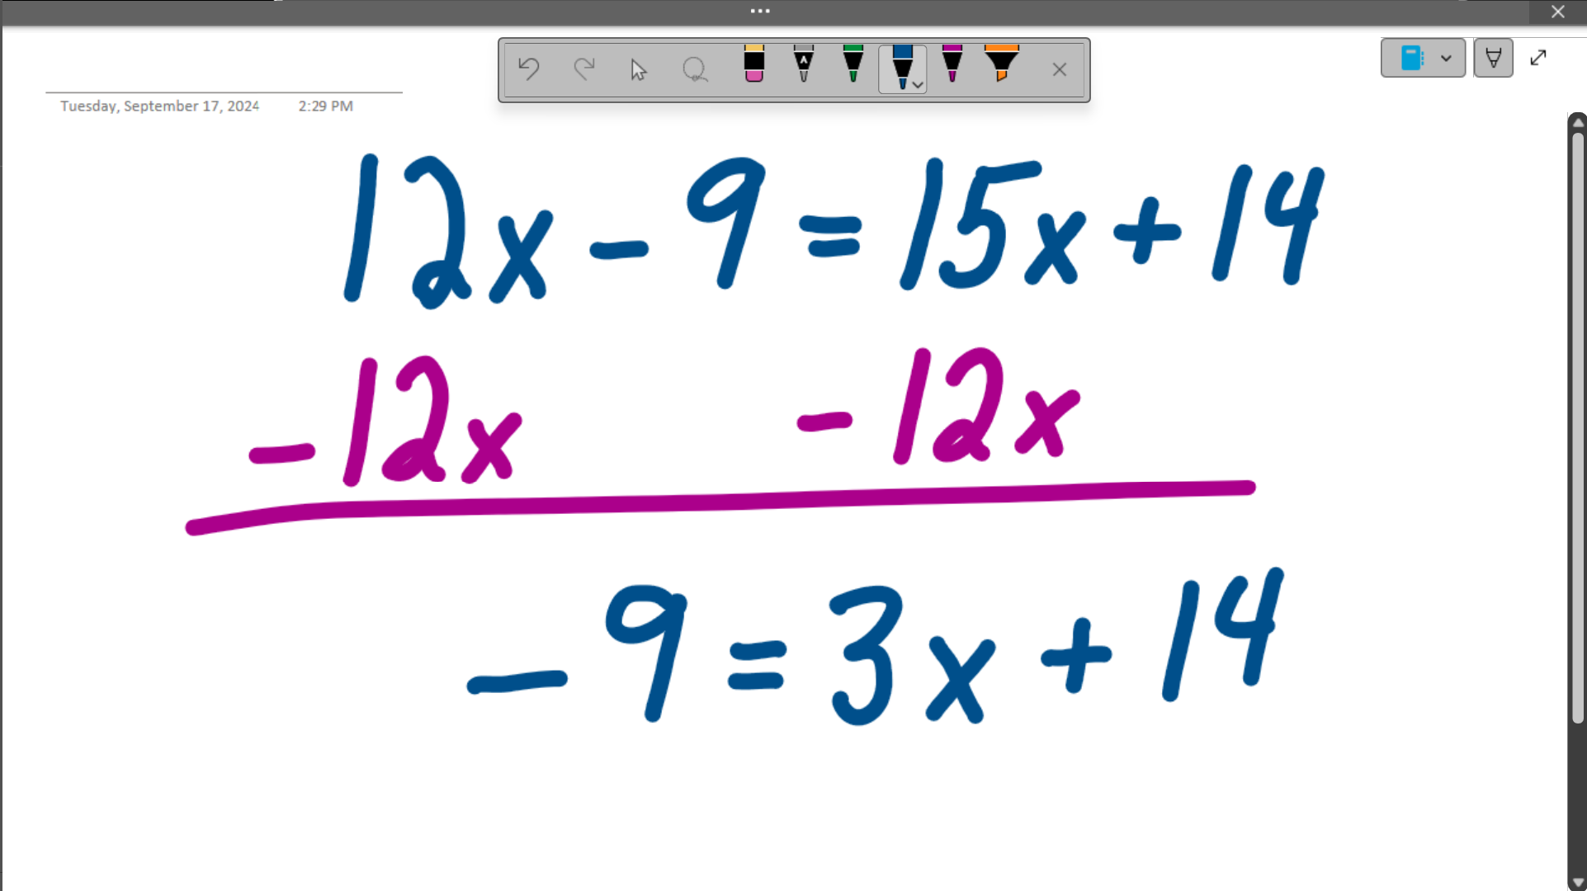
Subtract 14 from both sides. | 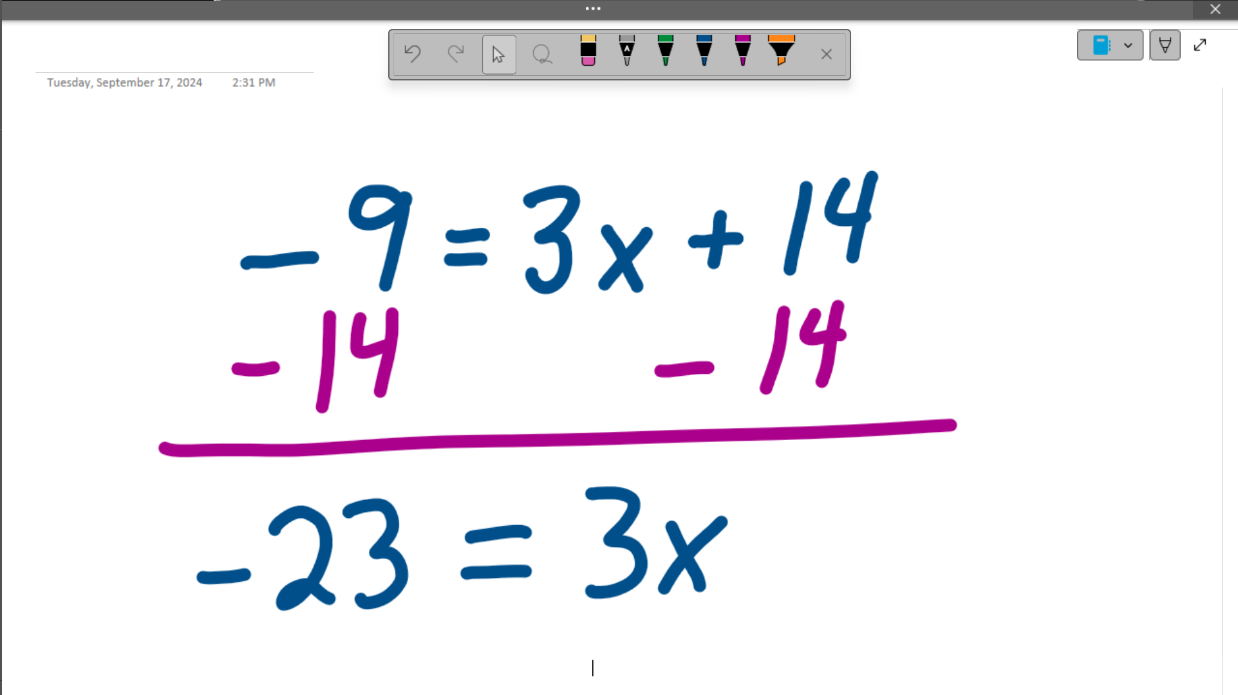
Divide both sides by 3.  The answer is $x=-\frac{23}{3}$. | 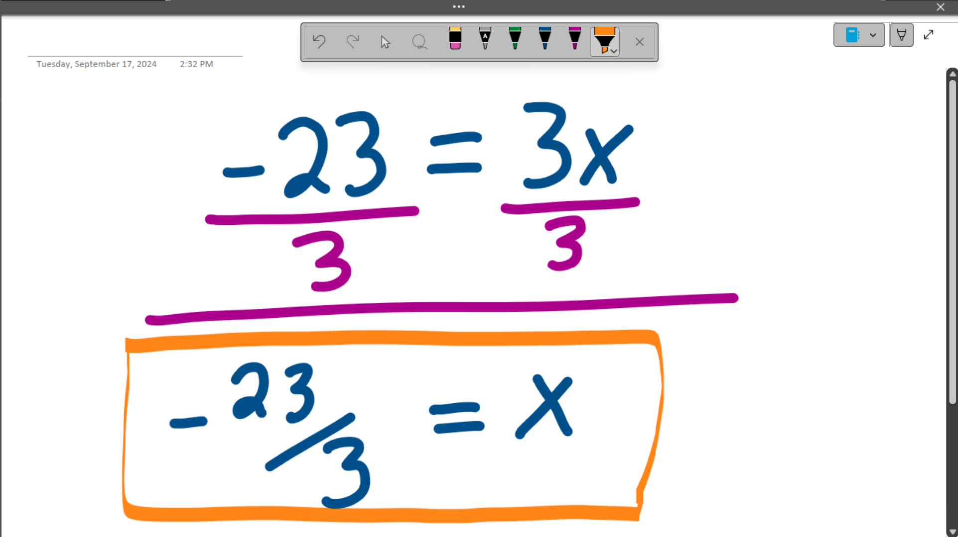

Solving a Linear Equation for a Variable
Adding more variables does not change the process of solving a linear equation. There are three facts to keep in mind while solving a linear equation with more than one variable. The first is that variables are numbers we do not know values for. The second is that you cannot combine a variable with a constant. The third is that your answer will be a formula and not a single number.

Example 5
Solve the equation for $x$.
$$qx+r=17$$

Solution
Step | Work
Subtract $r$ from both sides.  You cannot combine 17 and $r$. | 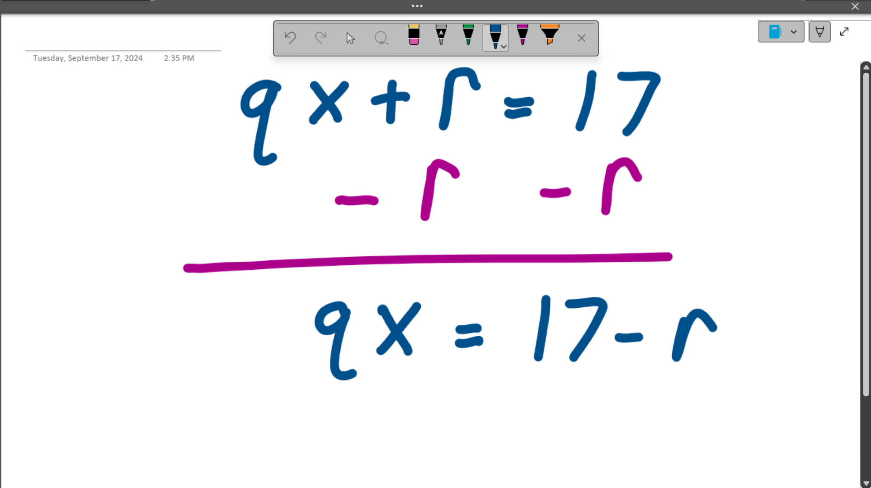
Divide both sides by $q$.  You cannot simply the right-hand side. Do not try to do too much. | 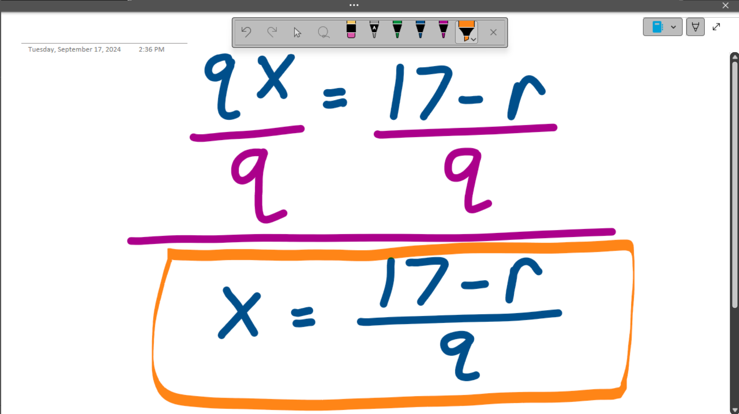

Example 6
Solve the equation for $b$.
$$d=wb+qb$$

Solution
Step | Work
Combine like terms.  You need to do this step because we are solving for $b$. If we were solving for a different variable, we would not have to do this step. | 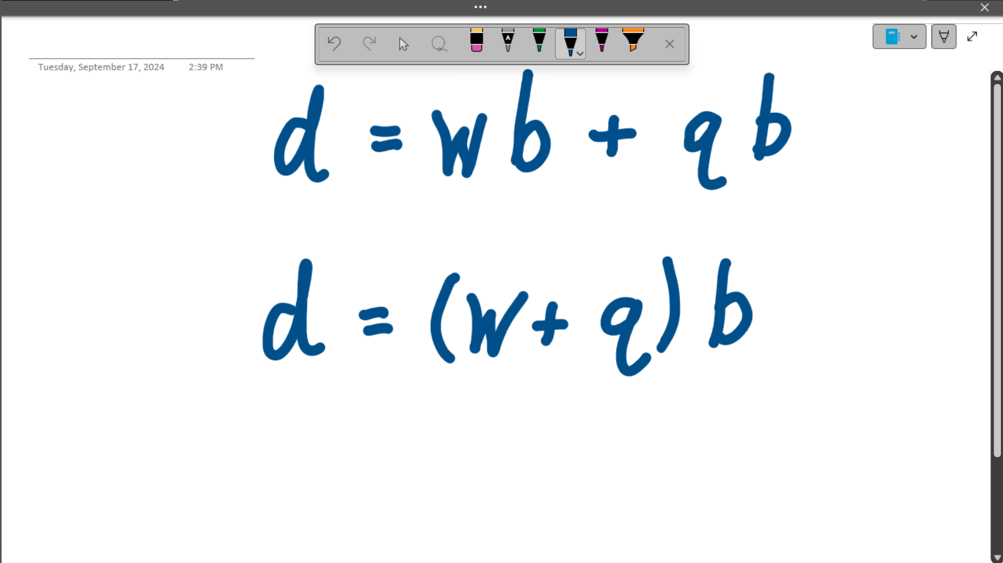
Divide both sides by $w+q$.  The expression $w+q$ is the coefficient of $b$. It does not look like a number, but we treat it like one. | 