Making and Using Tables
  - College Algebra

Introduction
Using a table of values for a function is a good way to see overall trends while seeing exact values. With a calculator, you can generate a table of values quickly.

Steps for Making Tables on Texas Instruments Calculators
To make a table of values with a TI graphing calculator, do the following:
- Rewrite the formula so that the independent variable is $x$ and the dependent variable is$y$.
- Press the Y= button on the calculator and type the formula for Y₁.
- Press 2ND and WINDOW to get to the TBLSET menu.
- Set the initial value for TblStart and the skip in the independent variable as ΔTbl.
- Press 2ND and GRAPH to see the table.

Example 1
For the first, example, we will make a table of values for the function $B=\frac{6t-1}{5t+2}$ for $t=3, 5, 7, …$.

Solution
The first step is to rewrite the formula using $x$ and $y$:
$$y=\frac{6x-1}{5x+2}$$
Notice that the values for the independent variable start at 3 and increase by 2. We will have to make that adjustment in the table settings.
The calculator steps are below. Please follow along with your calculator.
Calculator Steps | TI-84 Plus CE | TI-83 Plus
“2ND" →  “Y=”  TI-84 Plus uses “ALPHA” and “Y=” to enter fraction bar | 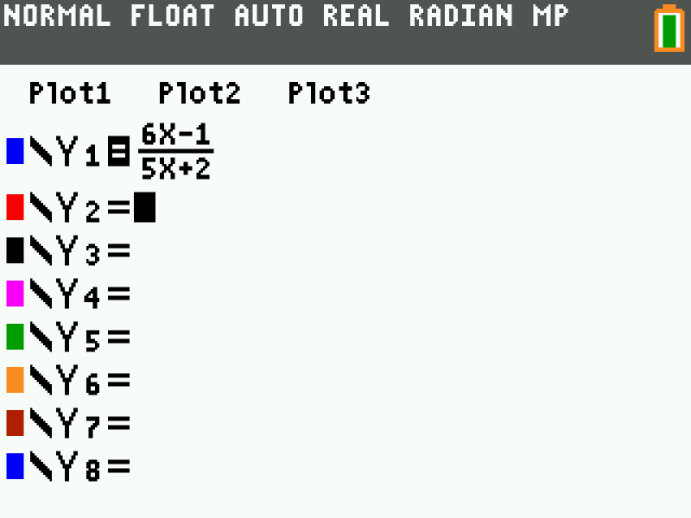 | 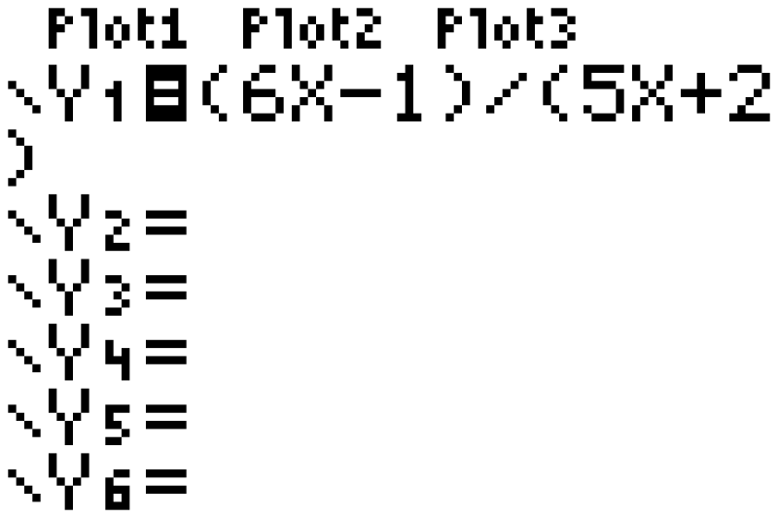
“2ND" →  “WINDOW”  Press down to access settings  TblStart = 3  ΔTbl = 2 | 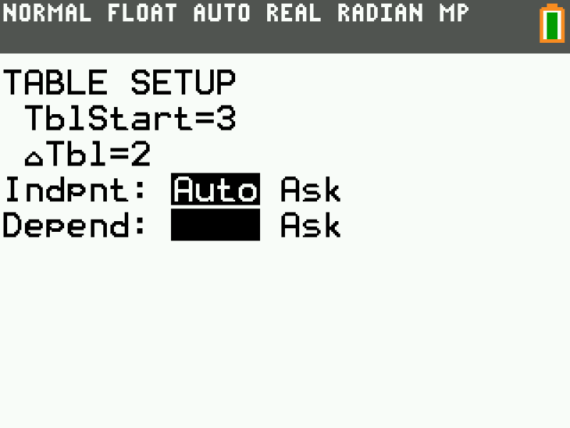 | 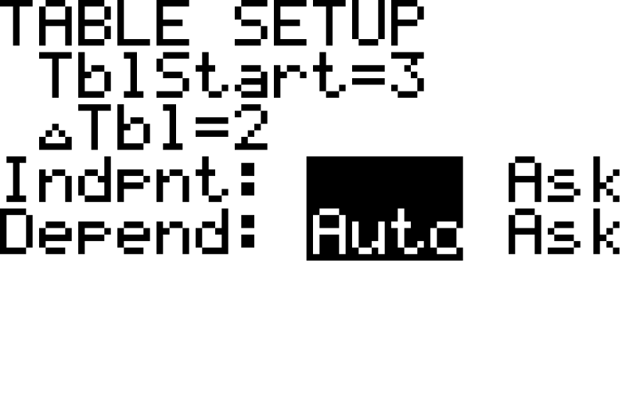
“2ND" →  “GRAPH” | 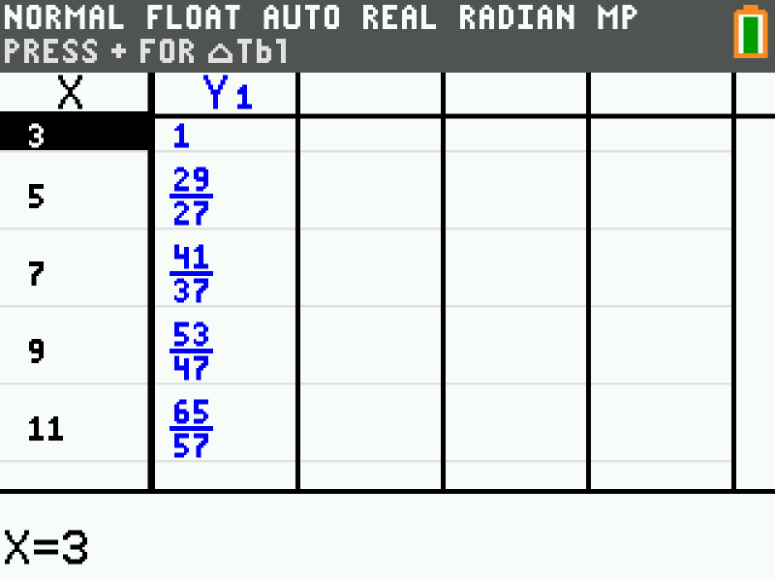 | 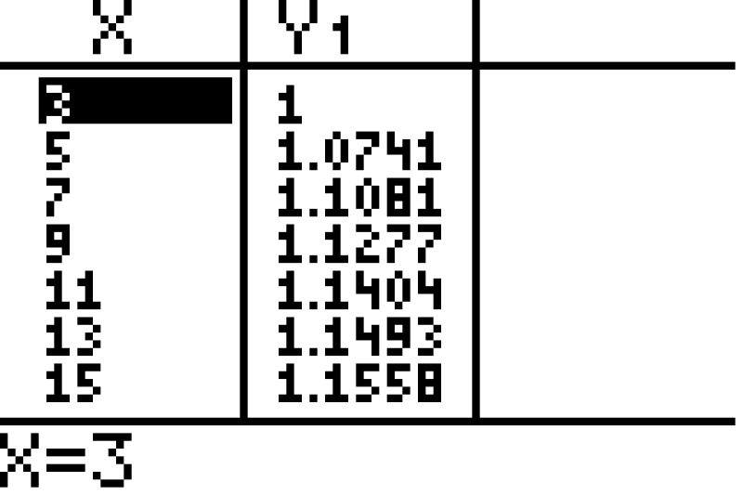
The TI-84 Plus family outputs fractions whenever you use the fraction bar. We want decimals for this course. One option is to type the function just like with the TI-83 Plus. The other is to use a calculator function to convert to decimals. The steps are below.
Calculator Steps | TI-84 Plus CE
“2ND" →  “Y=”  Go back to the Y= menu to edit the function. | 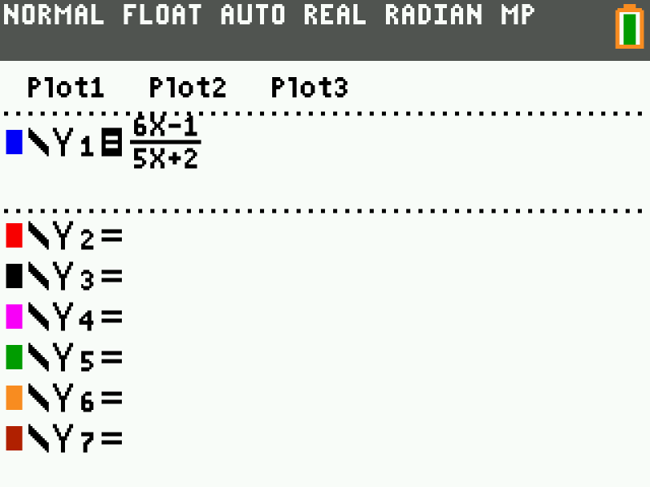
“MATH” →  2: ►Dec  Converts the answers to decimals | 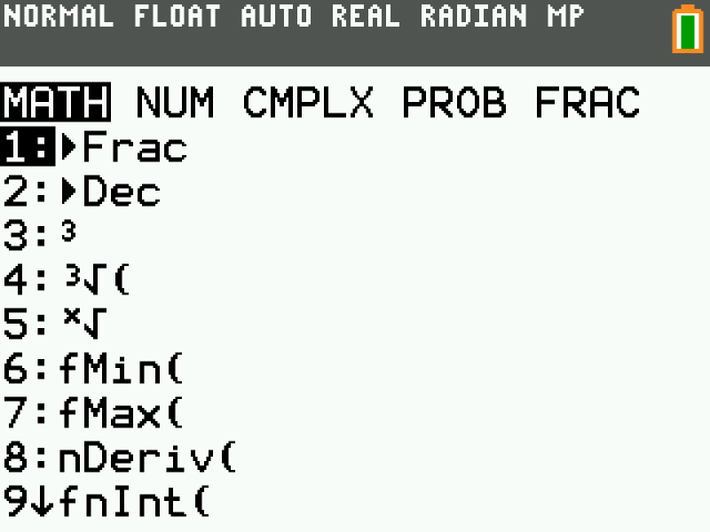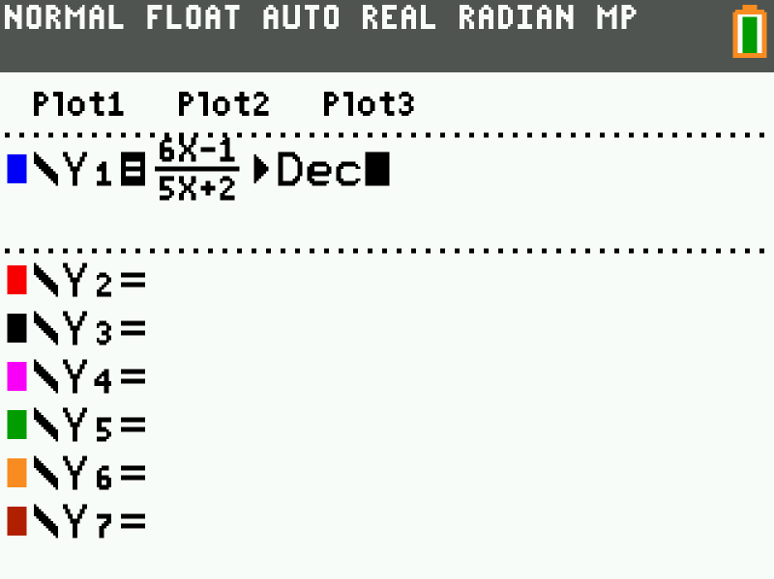
“2ND" →  “GRAPH”  The table is now in decimals | 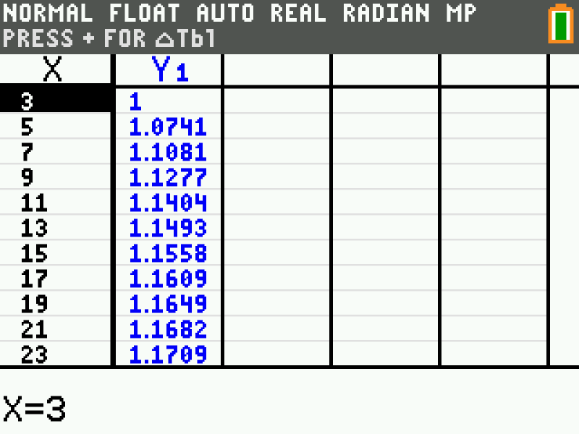

Example 2
For our second example, we will create a table of values for $y=\sqrt{x}-\frac{x}{20}$ for $x=0, 0.2, 0.4, …$.

Solution
The process is very similar to the last problem. Follow along on your calculator.
Calculator Steps | TI-84 Plus CE | TI-83 Plus
“2ND" →  “Y=”  TI-84 Plus uses “ALPHA” and “Y=” to enter fraction bar | 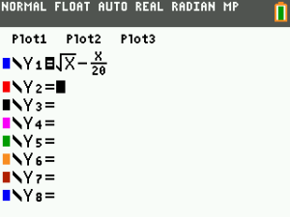 | 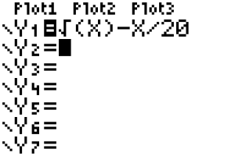
“2ND" →  “WINDOW”  Press down to access settings  TblStart = 0  ΔTbl = 0.2 | 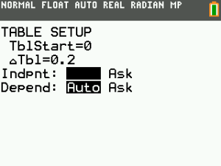 | 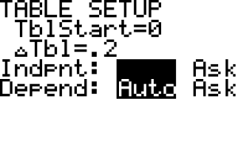
“2ND" →  “GRAPH”  This time, the TI-84 converts answers to decimals due to the square root. | 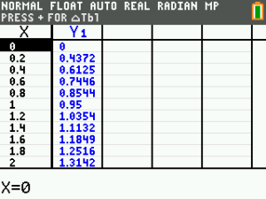 | 