Making and Using Graphs
  - College Algebra

Introduction
In the last section, we made tables for a function given by a formula. We will now make graphs from formulas.

Making Graphs on Texas Instruments Calculators
Graphing a function on a graphing calculator is relatively easy. We will have to spend some time setting up the viewing window. This is because graphing calculators are setup for traditional algebra classes by default.

Calculator Directions – Graphing a Function
To make a graph on a TI graphing calculator, do the following:
- Rewrite the formula so that the independent variable is $x$ and the dependent variable is $y$.
- Press the Y= button on the calculator and type the formula for Y₁.
- Press the WINDOW button to set the viewing window.
- Press the GRAPH button to display the graph.
Most of our work will go into finding the window settings.
(A quick aside: I realize that graphing calculators are considered old-fashioned now that programs like DEMOS exist. The reason I still like them is because you must know math to make them work. This is a math class, not a calculator class.)

Finding the Window Settings
The window settings determine how much of the graph we will see. You want to be able to focus on key features or give an overview of the function depending on your needs.

Calculator Directions – Setting a Viewing Window
- Determine the range of values for the horizontal axis. This will either be given to you in the problem, or you will have to infer it from the context.
- Make a table of values for the graph. This table will give you an idea of the highest and lowest values of the dependent variable. You will have to use the range of values for the horizontal axis from step 1 to make the table.
- Set the window variables. Press the “WINDOW” button and enter numbers for these variables:
  - Xmin – The left-most value on the horizontal axis.
  - Xmax – The right-most value on horizontal axis.
  - Ymin – The bottom-most value on vertical axis.
  - Ymax – The top-most value on vertical axis.
The variables Xscl and Yscl are not critical. They can make the graph look pretty by setting the spacing in the tick marks on the axes.

Examples of Graphing a Function

Example 1
For the first example, graph the function $f(x)=\sqrt{x}-\frac{x}{20}$ for $x$ between 0 and 10.

Solution
The calculator steps are below. Please follow along with your calculator.
Calculator Steps | TI-84 Plus CE | TI-83 Plus
Press “Y=” and enter the function formula. | 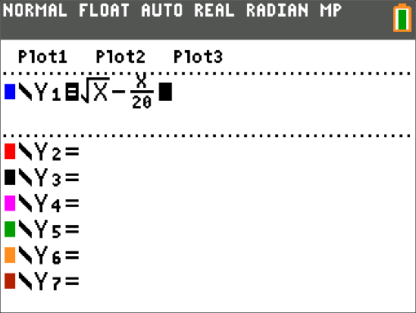 | 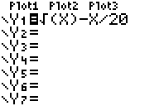
“2ND" → “WINDOW” to get to “TBLSET”  For x between 0 and 10, use: TblSart=0  ΔTbl = 2. | 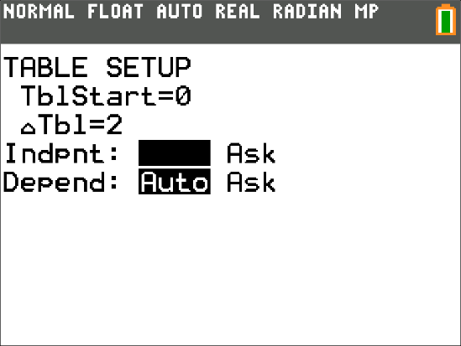 | 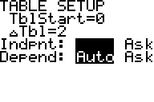
“2ND" → “GRAPH” to get to “TABLE”  For this function, the lowest y value is 0 and largest is 2.66. | 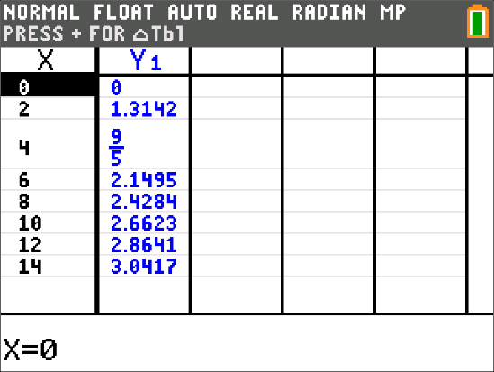 | 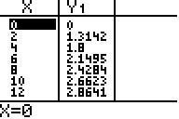
“WINDOW”  From the directions, use 0 for Xmin and 10 for Xmax.  From the table, use 0 for Ymin and 2.8 for Ymax. You do not have to be precise with the y-values. | 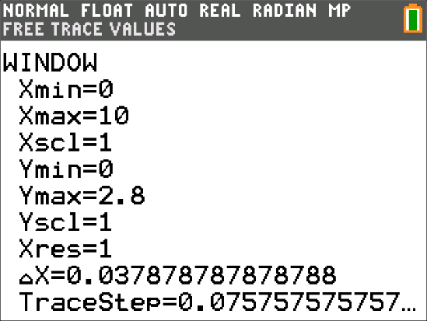 | 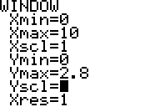
“Graph”  The graph is displayed. If you have any gaps, revise the window settings. | 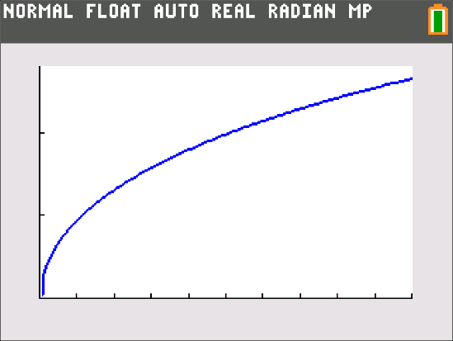 | 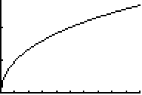

Example 2
Graph the function $f\left(x\right)=-0.22x^{2}+21.3x+20$ for $x$ between 0 and 100.
Calculator Steps | TI-84 Plus CE | TI-83 Plus
Press “Y=” and enter the function formula. | 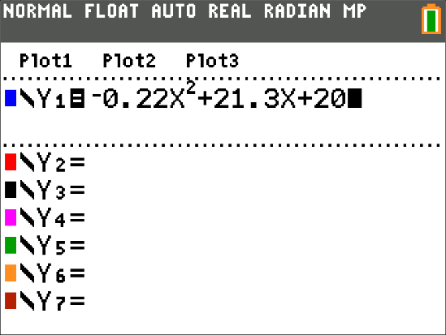 | 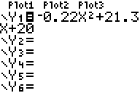
“2ND" → “WINDOW” to get to “TBLSET”  For x between 0 and 100, use: TblSart=0  ΔTbl = 10. | 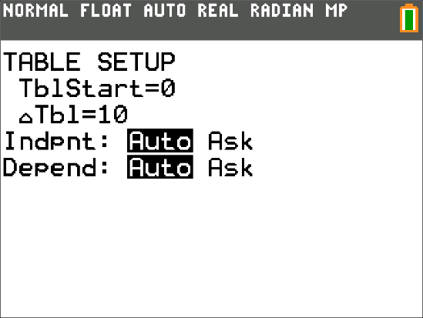 | 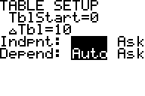
“2ND" → “GRAPH” to get to “TABLE”  For this function, the lowest y value is -50 and largest is 535. | 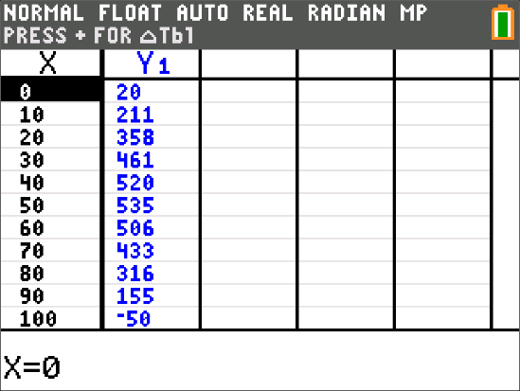 | 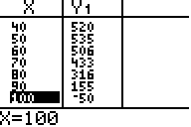
“WINDOW”  From the directions, use 0 for Xmin and 100 for Xmax.  From the table, use -60 for Ymin and 550 for Ymax. You do not have to be precise with the y-values. | 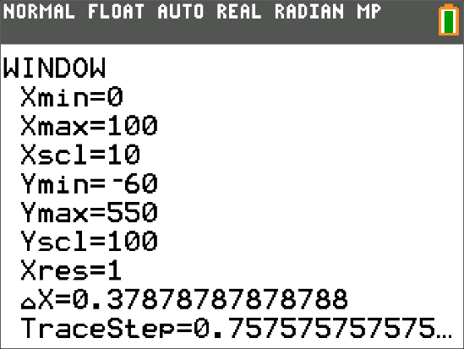 | 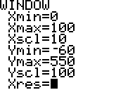
“Graph”  The graph is displayed. If you have any gaps, revise the window settings. | 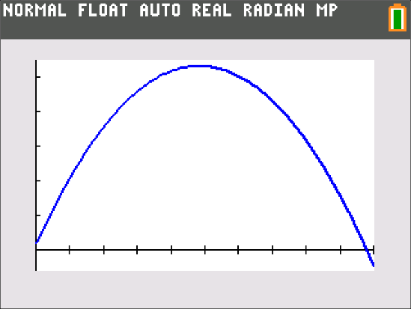 | 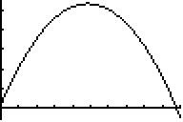

Tracing On a Graph
Once you have a graph, you can answer many questions about the function. You will need exact function values to get the information to answer these questions. The trace feature on your calculator will allow you to access specific function values.

Calculator Directions – Using the Trace Function
- To use the buttons to trace a graph, press the “TRACE” button. Press the left and right buttons to move the cursor along the graph. The x-coordinate and y-coordinates are displayed on the bottom.
- To evaluate the function for a specific x-value, type “TRACE” and then the value for $x$.

Examples
Some examples of tracing a graph are shown below using the graphs from Example 2.
Calculator Steps | TI-84 Plus CE | TI-83 Plus
Press “TRACE” and press the right arrow a few times. | 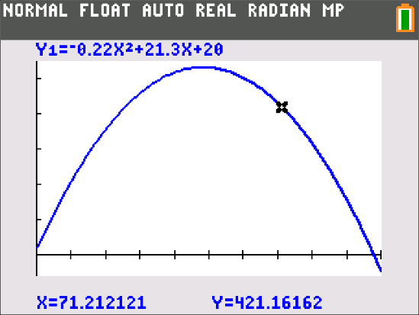 | 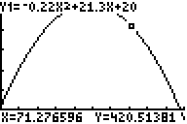
Press “TRACE” and type 40. | 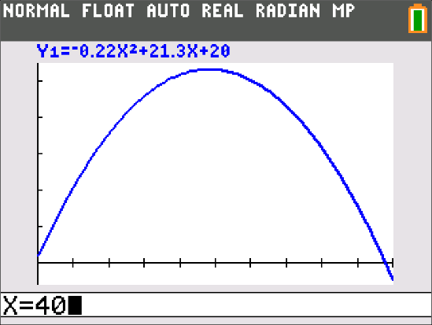 | 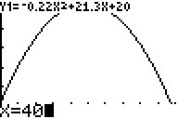
Then type “ENTER”.  The cursor moves to a x-coordinate of 40. The y-coordinate of 520 is the function value. | 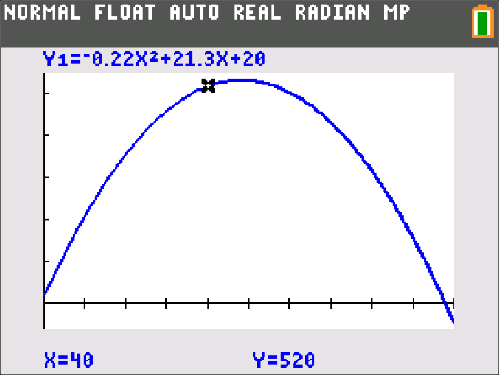 | 